Excavated Gilt-Bronze Phoenix Padlock at Hwangnyongsa Temple Site fromthe Silla and Goryeo era
- The Gyeongju National Research Institute of Cultural Heritage, Online Presentation of the Result of the Excavation in the Western Part of the West Corridor-

The Gyeongju National Research Institute of Cultural Heritage
Researcher Park Sung-Jin (054-777-8805),
Researcher Jeong Yeo Seon (054-622-1740)

The Gyeongju National Research Institute of Cultural Heritage (the GNRICH, Director Lee Jong-Hoon), under the Cultural Heritage Administration,will unveil ‘the result of the excavation in the western part of the west corridor,’ is an academic research project for Silla temples, at 2 pm on November 25th through the YouTube channel of the GNRICH (https://youtu.be/FvEpWuZCvog).

Hwangnyongsa Temple site (Historical site no. 6) in Gyeongju was excavated by the Gyeongju Historical Remains Excavation Research Group (present the GNRICH) from 1976 to 1983. The Gyeongju Historical Remains Excavation Research Group discovered central area, where a Geomdang (a golden hall) and a wooden Top (a wooden pagoda) were located, and the north part of the Geomdang. An Office of the research team was located in the west area of the west corridor, and it was only a place in the whole temple site that remained an undiscovered area. This area has been estimated as where living places for monks might be located, or facilities for the temple operation might be located.
The GNRICH has first excavated the northern part of the undiscovered area in the west part of the west corridor (about 8,700m²) since 2018. The excavation including many features such as building sites, drainages, walls, and abandoned roof tiles dating from the Unified Silla to Goryeo. In particular, the building sites are overlapped on the layers; the upper layer from the Goryeo era and the lower layer from the Unified Silla era. As they were overlapped, it helps to understand the trends of space composition and arrangement of buildings outside Hwangnyongsa Temple.

A 35.5-meter-long wall, built in the north-south direction from the Goryeo period, was identified about 9m away from the west part of the west corridor. It was built based on square stones of 30-50cm in length, and after leveling it by piling several layers of sizable concave roof tiles on it. Then, stones or bricks were stacked on top again. Based on this wall, it appears to have divided the east and the west. It is assumed that it was built to separate the worship area inside the corridor and the living space outside the corridor. Furthermore,on the lower layer of the building sites in the Unified Silla era, a layer of fine gravels about 5-10cm in size and yellow clay was exposed. This trace seems to be the base of the road. This discovery is expected to beessential data to determine whetherthe west of Hwangnyongsa Temple was expanded further or not if the trace was a road feature in the north-south direction.

On the other hand, in this research, a number of roof tiles, earthenware, and metal artifacts used in the Three Kingdoms and Goryeo period were excavated. Three pieces of gilt-bronze and iron padlocks are particularlynoted. It is an unusual phenomenon that three padlocks from the Unified Silla and Goryeo period were discovered within the small research area.It seems those padlocks to besignificant data for clarifying the function of the west corridor’s outer spaces.

In particular, a 6cm-long gilt-bronze phoenix padlock excavated from the lower layer of building sites in the Unified Silla era is evaluated as a very characteristic artifact that has not been found so far. The cast gilt-bronze padlock is believed to be a valuable item as it was delicately made to express the scales and feathers of the phoenix in detail.

Therefore, the area appears to have been equipped with devices or facilities to store crucial items related to the temple. It is expected that thenature and function of this area will become more apparentas further excavation at this area continues in the future.

This excavation result is published online to share cultural heritage when it is difficult to visit the excavation site directly due to Covid-19. Anyone can visit the GNRICH YouTube channel to watch videos about unearthed features and artifacts.

The Cultural Heritage Administration’s the Gyeongju National Research Institute of Cultural Heritage will continue to conduct research and investigation on Hwangnyongsa Temple and other temple sites in the Silla capital, and identify the space, function and scenery of the Silla capital. Moreover, the GNRICH plans to expand opportunities for sharing excavation results with the public like this online presentation.

Photographs

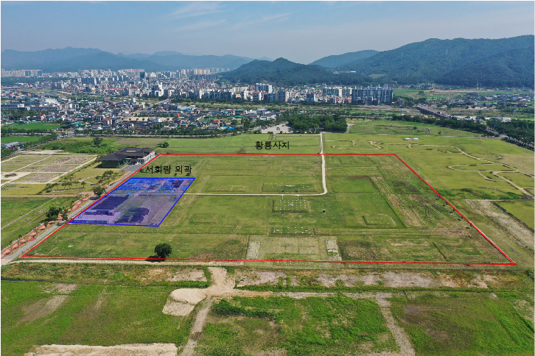
<Panorama of the Research Area>
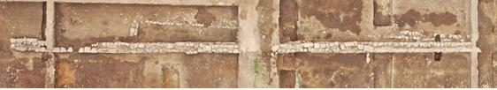
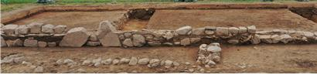 | 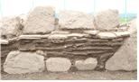
<Wall no. 8>
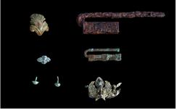 | 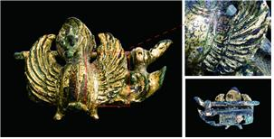
<Gilt-Bronze Phoenix Padlock and other excavated metal artifacts>

