담당부서: Archaeological Studies Division, National Research Institute of Cuitural Heritage
담 당 자: Yongmin Kim Senior Researcher (042-860-9172), Iseul Shin Senior Researcher(042-860-9180)
The National Research Institute of Cultural Heritage publishes 2019 Journal of Korean Archaeology
- containing results of excavations of 26 national sites which have received a great amount of attention from academia and the media in 2019 -

The National Research Institute of Cultural Heritage (Ji Byongmok, Director General) of the Cultural Heritage Administration, has published the Korean and English editions of the 2019 Journal of Korean Archaeology, a compilation of reports in form of a journal containing major excavation results of Korean Archaeology, and holds a conference introducing the ‘results of the major national archaeological sites 2019’ within the scope of the 44th Annual Conference of the Korean Archaeological Society, on 10:00 am on November 7, at the Chungnam National University.

2019 Journal of Archaeology consists of accomplishments from home and abroad, selected by experts of archaeology and cultural heritage among the archaeological excavation results of 2019, which have received a lot of attention from academia and the media. It contains 26 national sites from the Danghang-ri Bronze Age site to the Gimhaeeupseong Joseon Town Wall, and the Duurlig Nars Site in Mongolia.

Furthermore, fascinating articles on a sensational way to shed light on the ancient subsistence activities by analysing the organic residues collected from soil samples and potteries, and the conservation process of the bronze spearheads and halberd from the Yangji-ri Site in Gyeongsan were included.

Other than these, VR images of four excavation sites, which are difficult to access for ordinary people, including the Namsan-ri Section of the Jungseong Fortress in Ganghwa, were produced, so they can be experienced vividly without actually having to visit them. Further information are available on the website (360VR, http://vrnrich.kr/), also accessible by scanning the according QR-codes. Great store of information related to cultural heritage including academic conferences and statistics of 2019 are contained in this issue.
Results of nine amidst the sites introduced in the 2019 Journal of Korean Archaeology are scheduled to be presented at the Annual Conference of the Korean Archaeology Society, taking place on the 7th, and 50 people in order of the application on the website (http://kras.or.kr/), can take part in order to prevent the spread of COVID-19. The conference will be broadcasted online via Youtube live streaming on the official Youtube channale of the National Research Institute of Cultural Heritage.
*Online live stream: 10:00 am – 3:30 pm, November 7 (https://www.youtube.com/nrichpr)

The National Research Institute of Cultural heritage as part of ‘government innovation’ is contributing to the promotion of the most recent achievements of Korean Archaeology inside and outside of the country, and stimulation of academic exchanges by annually publishing Korean and English editions of the Journals of Korean Archeology since 2006. The issue of this year as well will be distributed to national and public libraries and research institutions in- and outside of the country and made available online on the website of the NRICH, (www.nrich.go.kr, Cultural Heritage Research Knowledge Portal) for public access.

The National Research Institute of Cultural Heritage of the Cultural Heritage Administration, as an executive agency, will strive to provide publicity to the research data and make efforts for national and international experts as well as the public to apprehend the achievements and values of our cultural heritage more easily and conveniently, reflecting the demands of the times.

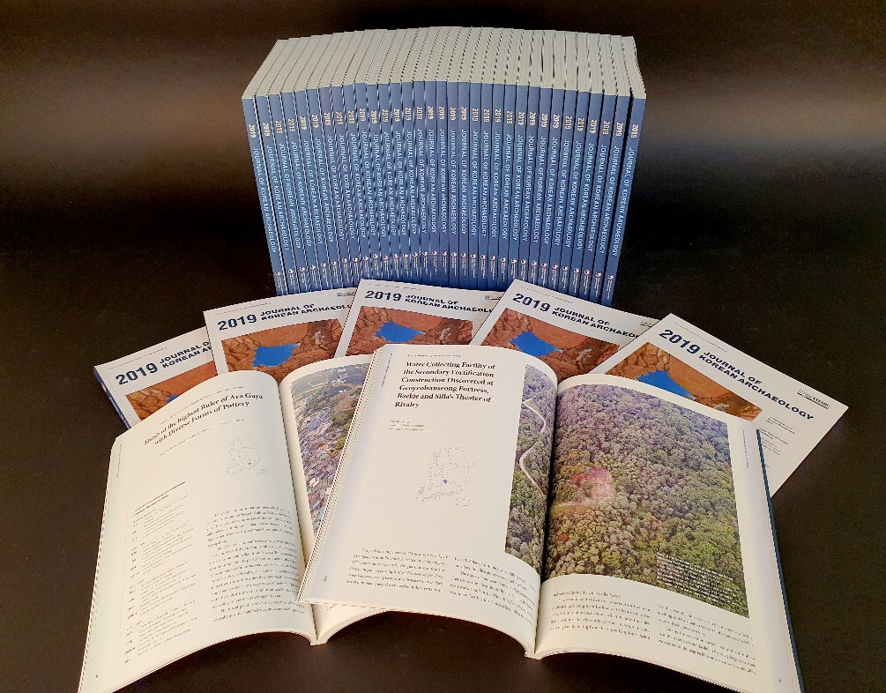
Figure 1_ 2019 Journal of Korean Archaeology
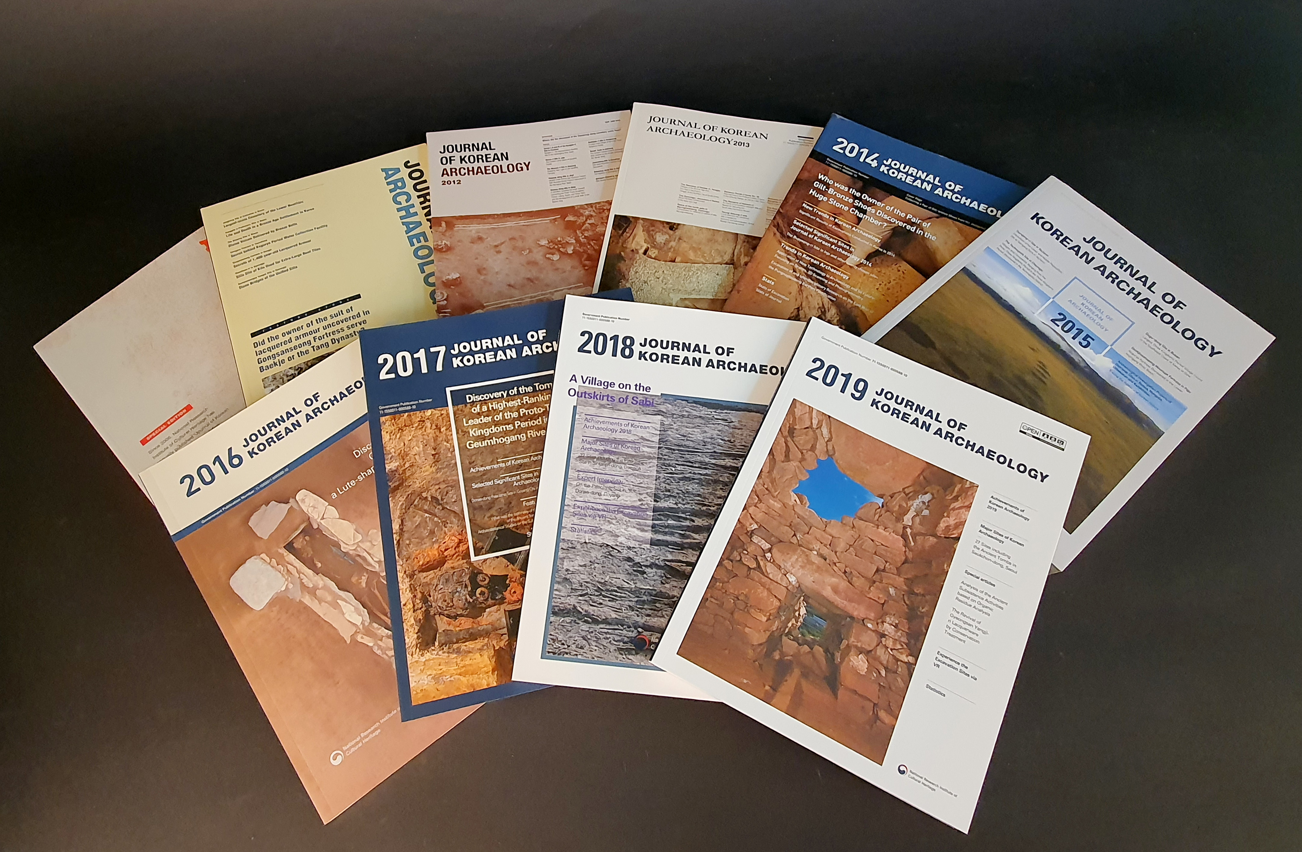
Figure 2 _ English editions of Journals of Korean Archaeology published up until this year

